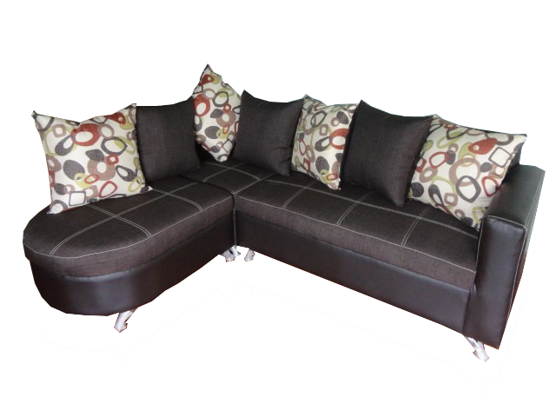

|  |  |  |  |
| --- | --- | --- | --- |
|  | **Ancho** | **Alto** | **Fondo** |
| **Sofá** | **1.55** | **.89** | **.81** |
| **Esq.** | **.81** | **.89** | **.81** |
| **Chaise** | **1.00** | **.89** | **.81** |



Sala Mod. Londonesa Chaise Izq.

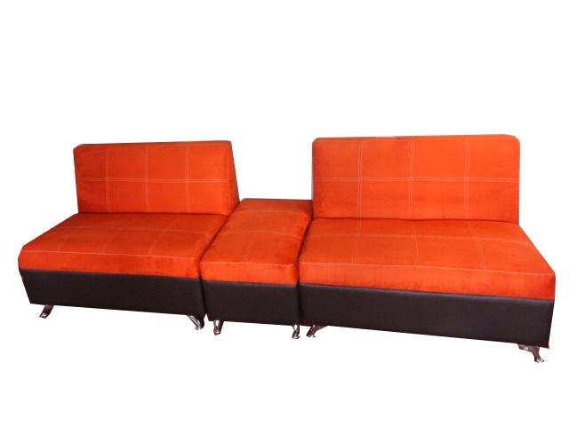



Sala Mod. Rebeca

|  |  |  |  |
| --- | --- | --- | --- |
|  | **Alto** | **Ancho** | **Fondo** |
| **Love** | **.90** | **1.16** | **.80** |
| **Taburete** | **.48** | **.80** | **.50** |

**Catálogo**

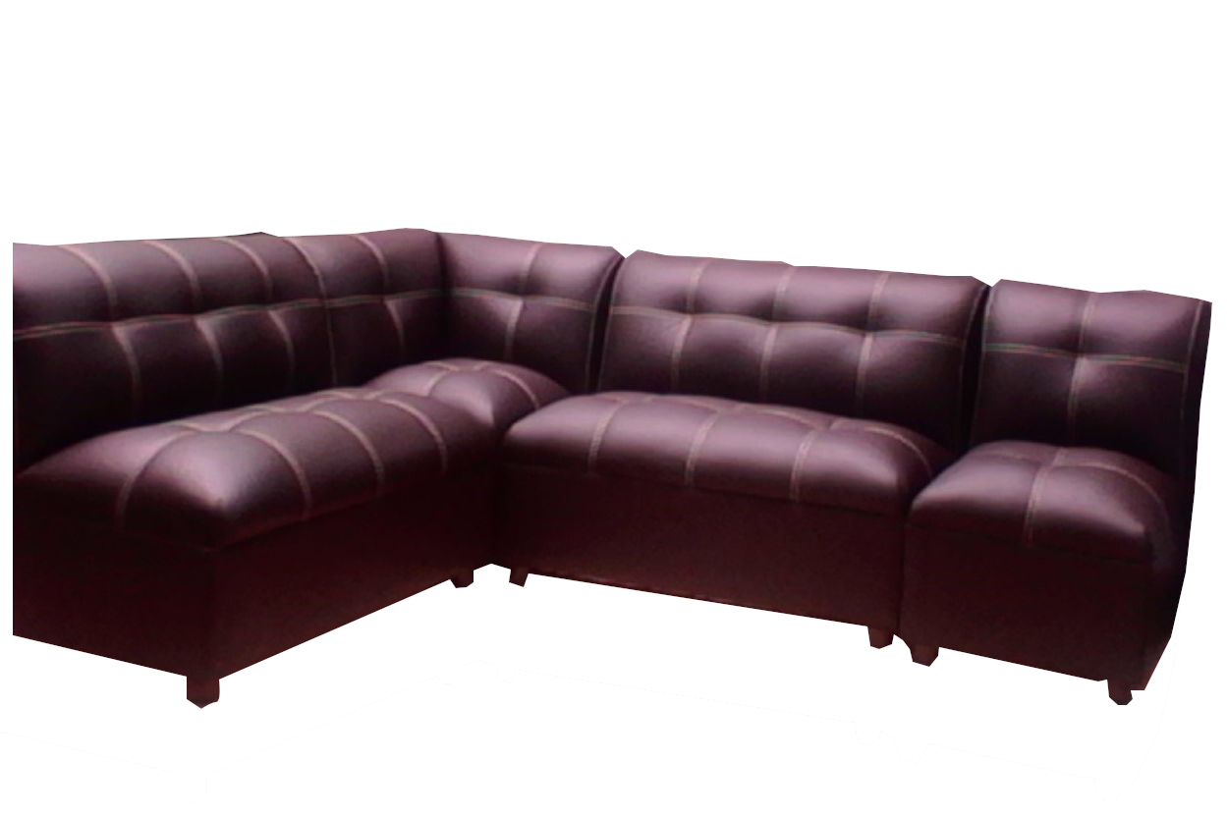



|  |  |  |  |
| --- | --- | --- | --- |
|  | **Ancho** | **Alto** | **Fondo** |
| **Sofá** | **1.10** | **.86** | **.80** |
| **Esq.** | **.80** | **.86** | **.80** |
| **Silla** | **0.55** | **.86** | **.80** |

Sala Mod. Palermo

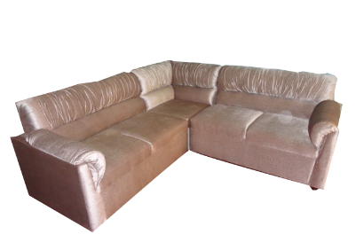



|  |  |  |  |
| --- | --- | --- | --- |
|  | **Alto** | **Ancho** | **Fondo** |
| **Love** | **1.22** | **.86** | **.76** |
| **Esq.** | **.76** | **.86** | **.76** |

Sala Mod. San José

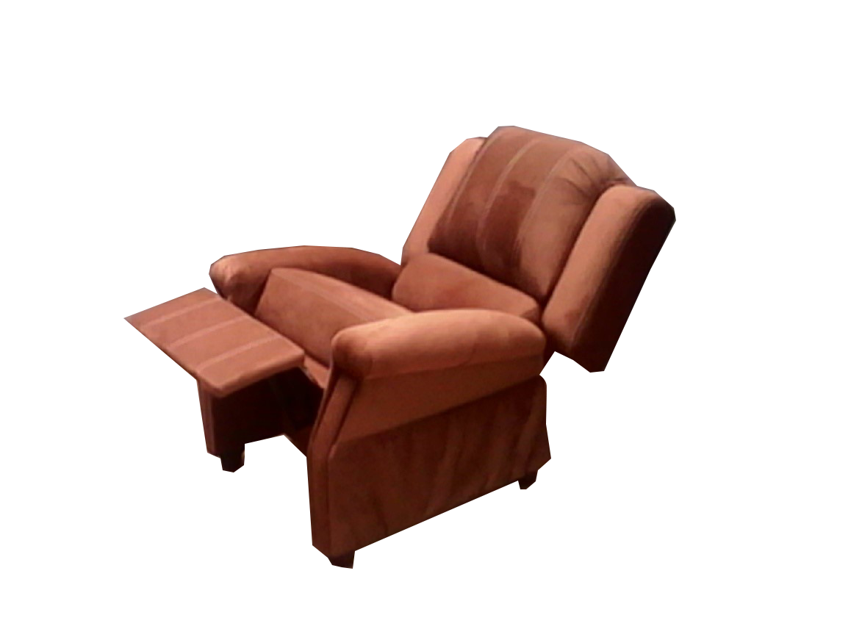



|  |  |  |  |
| --- | --- | --- | --- |
|  | **Ancho** | **Alto** | **Fondo** |
| **Sofá** | **1.86** | **1.00** | **1.00** |

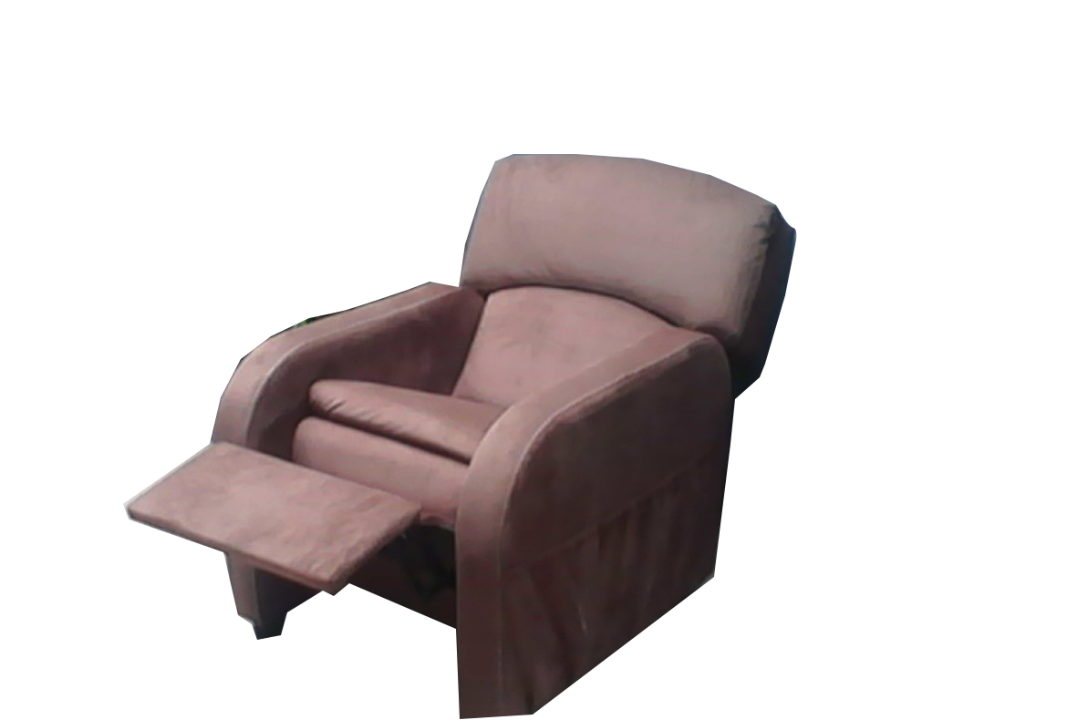

Reclinable Toronto

|  |  |  |  |
| --- | --- | --- | --- |
|  | **Ancho** | **Alto** | **Fondo** |
| **Sofá** | **.85** | **1.02** | **.82** |



Sillón Reclinable Mod. Senna

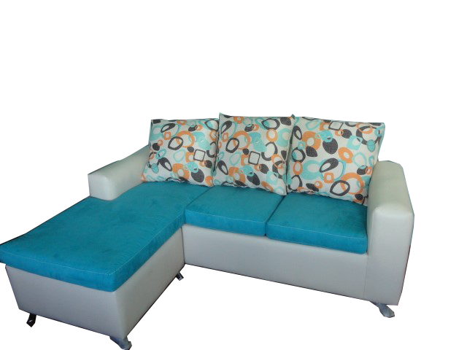



|  |  |  |  |
| --- | --- | --- | --- |
|  | **Alto** | **Ancho** | **Fondo** |
| **Sofá** | **.86** | **2.17** | **.83** |
| **Chaise** | **.55** | **.77** | **.70** |

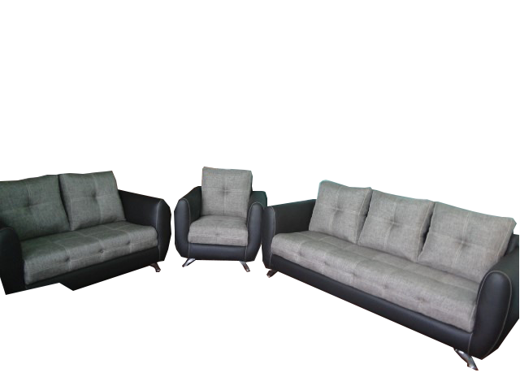

Sala Mod. Jazmin Chaise Long

|  |  |  |  |
| --- | --- | --- | --- |
|  | **Ancho** | **Alto** | **Fondo** |
| **Sillón** | **.90** | **.90** | **.85** |
| **Love** | **1.50** | **.90** | **.85** |
| **Sofá** | **2.10** | **.90** | **.85** |



Sala Mod. Valencia

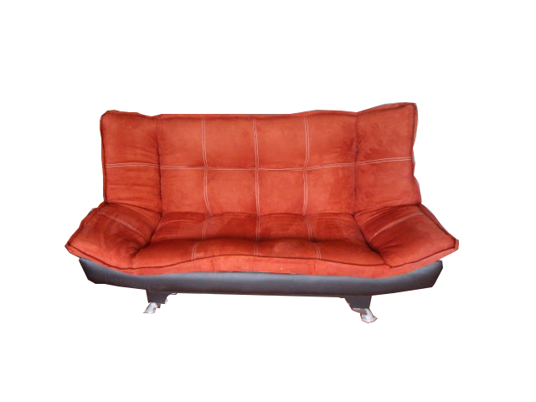



|  |  |  |  |
| --- | --- | --- | --- |
|  | **Alto** | **Ancho** | **Fondo** |
| **Sofá** | **1.86** | **1.00** | **1.00** |
| **Cama** | **1.86** | **.50** | **1.20** |

Sofá Cama Mod. Milán

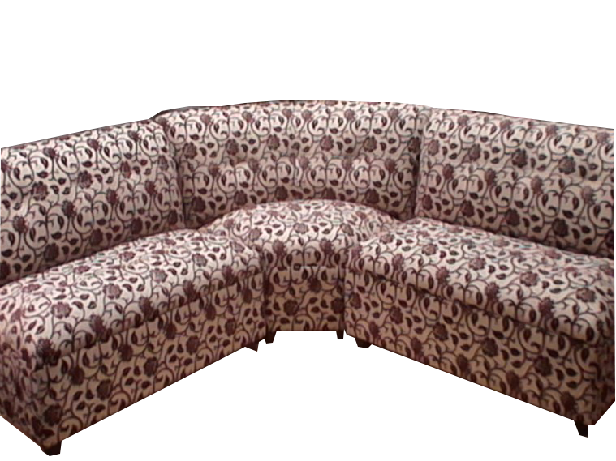



|  |  |  |  |
| --- | --- | --- | --- |
|  | **Alto** | **Ancho** | **Fondo** |
| **Love** | **1.10** | **.80** | **.75** |
| **Esq.** | **1.50** | **.80** | **.75** |

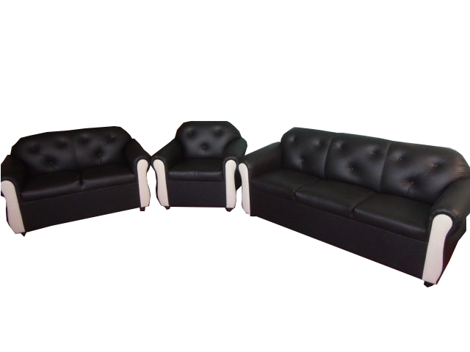

Sala Mod. Karen 2-2-E

|  |  |  |  |
| --- | --- | --- | --- |
|  | **Ancho** | **Alto** | **Fondo** |
| **Sillón** | **.90** | **.75** | **.75** |
| **Love** | **1.30** | **,75** | **.75** |
| **Sofá** | **1.80** | **.75** | **.75** |



Sala Mod. San Isidro

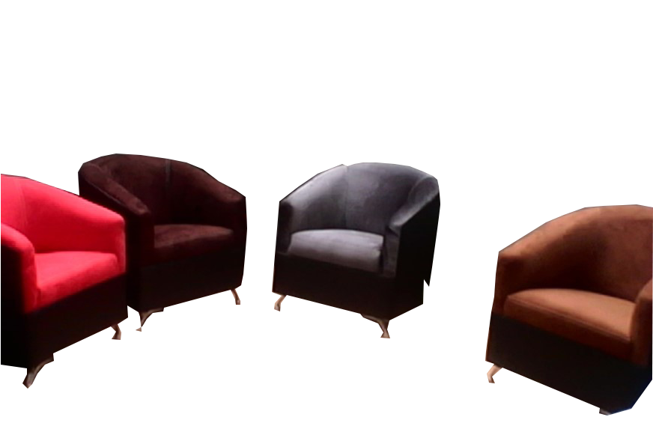

|  |  |  |  |
| --- | --- | --- | --- |
|  | **Ancho** | **Alto** | **Fondo** |
| **Sillón** | **.78** | **.86** | **.80** |



Sillón Mod. Vallarta

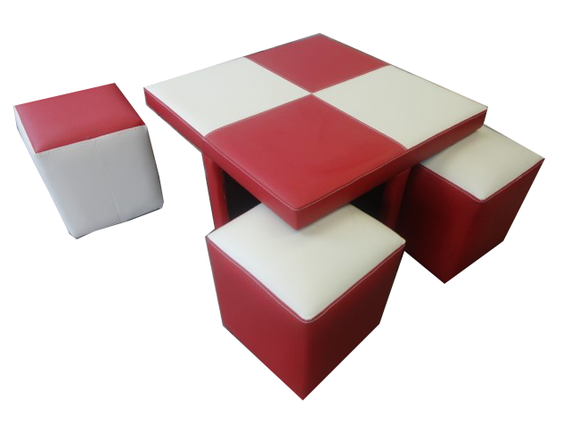

|  |  |  |  |
| --- | --- | --- | --- |
|  | **Alto** | **Ancho** | **Fondo** |
| **Mesa** | **0.80** | **.50** | **.80** |
| **Tab.** | **0.37** | **.40** | **.37** |



Mesa De Centro C/ Taburetes

|  |  |  |
| --- | --- | --- |
|  |  |  |
|  |  |  |

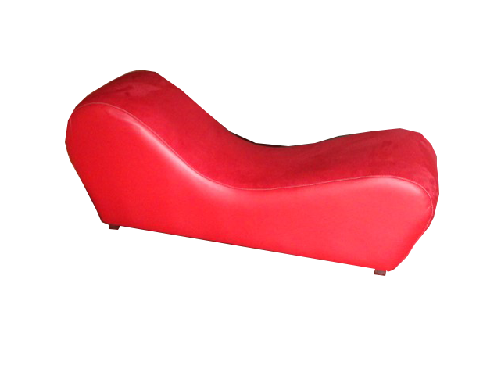

Diván de Descanso